**CMR Institute of Technology** 

**Kandlakoya Village, Medchal Rd, Hyderabad, Telangana 501401**

**Institute Innovation cell**

**Developing Online Repository of Ideas Developed and Wayforward plan**

**Team Name:**

Members:

1. Seelam Meghana :20R01A04A9

2. Shaik Farhana :20R01A04B0

3. Sindhuri Daraveni :20R01A04B1

4. Soumya Sri :20R01A04B2

5. Thatipamula Manogya:20R01A04B6

Idea Title: Domestic Gas Leakage Detector Problem Statement:

To detect Domestic Gas Leakage through sensor and to get a alert call when detection takes place.

**OVERVIEW**

LPG cylinder are commonly used in India. LPG is highly inflammable and can burn even at some distance from the source of leakage. Most fire accidents are caused because of a poor-quality of rubber tube or the regulator is not turned off when not in use. Therefore developing a gas leakage alert system is very essential.

**GOALS/Objectives**

1. We can reduce fire blast caused due to LPG gas leakage.

2. We can also reduce many health disorders caused due to inhalation of LPG gas when leakage takes place.

3. We can save property loss and life loss caused due to explosion of gas. **SPECIFICATIONS**

From this gas leakage detector device we can sense the gas leakage through sensor and GSM technology is used to send alert call when leakage takes place. This is a wireless device which detects LPG gas when it exceeds certain level as the program is coded in the specific device.

**MILESTONES**

**1. Ideation/Data collection**

LPG fire blast is one of the major problem which causes over explosion. In order to sort out this problem we taught to construct a device through which gives us a alert siganl so that we can overcome this problem. Here came up with a device **“Gas Leakage Detector ’’** to sort out this problem.



Fig 1: Problem scenario

**2. Model Building**

Domestic gas leakage detector is a device which detects domestic gas leakage. When LPG gas in the certain area exceeds the limit 200ppm ,this device detects the danger and sends us the alert signal through phone call.

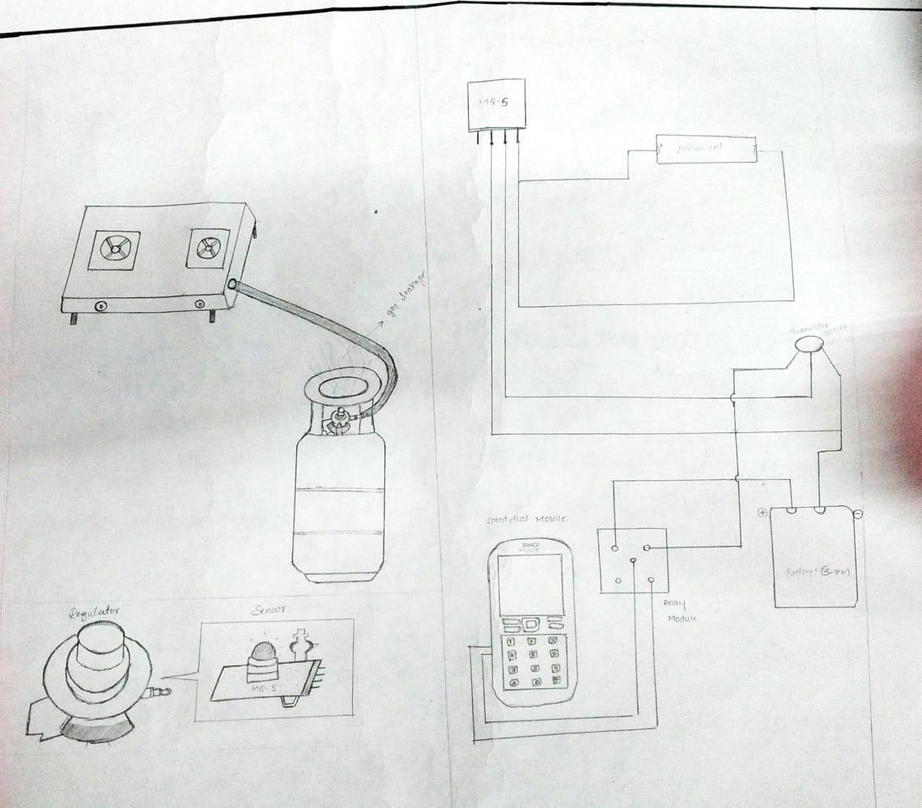Fig 2 Model or blueprint

**3. Components/Tools Understanding and usage**

This device consists of a Sensor ,Arduino ,Controller ,LED ,Speed dial mobile .Here specific limit and the operations are coded in the arduino which senses gas leakage when it exceeds certain level. Sensor is a device which detects the gas leakage and informs us about the condition. Through LED we could easily understand the working of the system. And controller helps us to operate the system in the necessary conditions only.

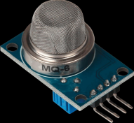

Fig 3.1: sensor

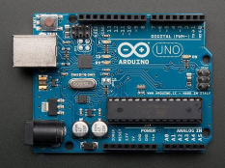Fig 3.2 :Arduino

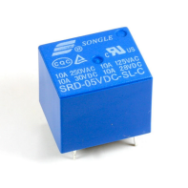Fig 3.3: Relay